Summit for Stanford Larsen Memorial Scholarship Fund
Mt. Washington, January 19th

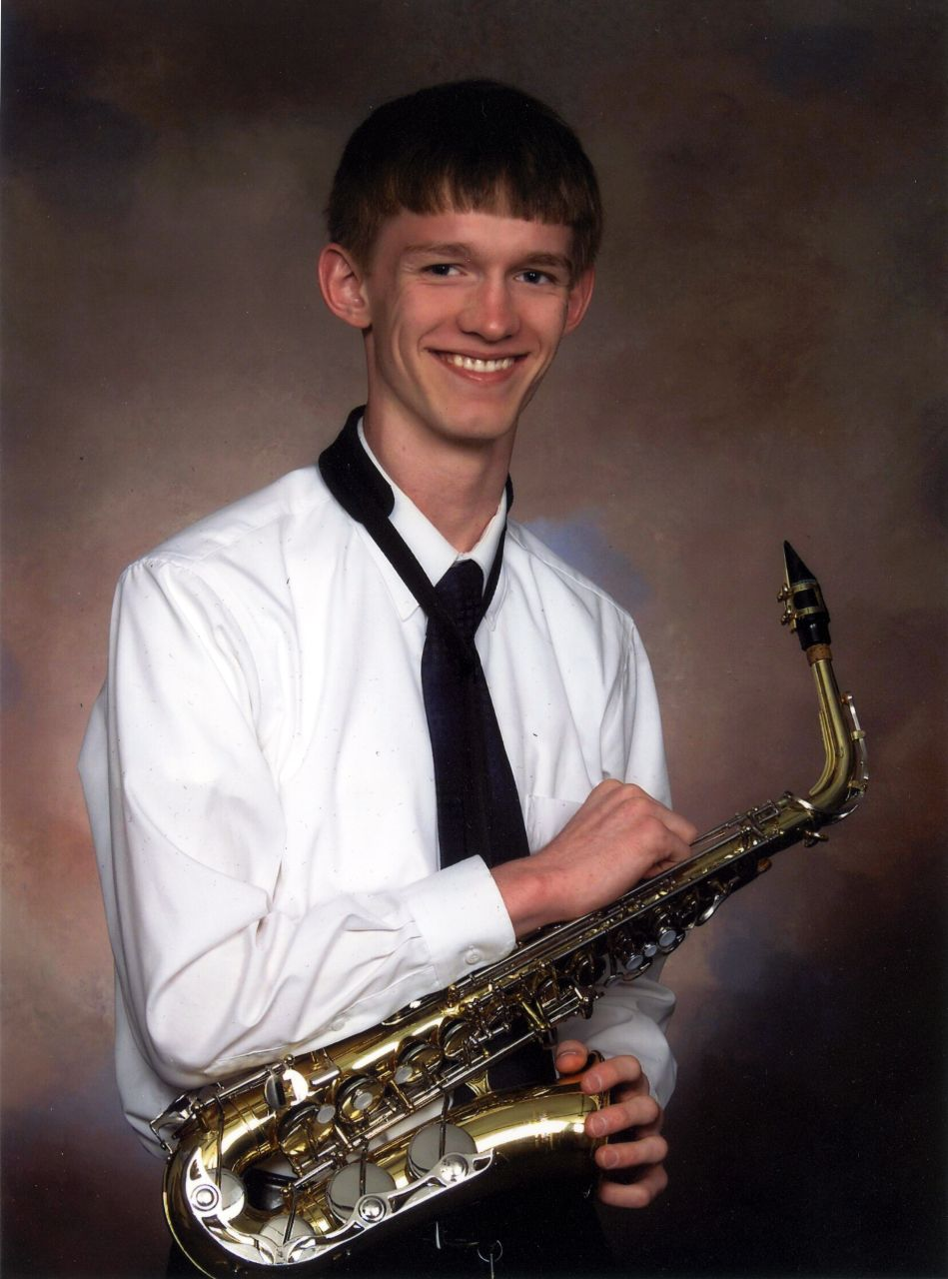
I am planning my second annual Mt. Washington climb.
I am climbing in memory of Stanford Larsen. Please read
below to understand why keeping his memory alive
through a scholarship fund is so important.

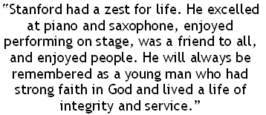

For more information go to www.stanfordlarsen.org

Currently, the summit conditions are as follows:
Temperature: -10° F

Wind: NW 72 mph
Visibility: 300 ft to 80 miles
Ground Conditions: 12” snow & ice

How to Contribute

Tax deductible donations should be made payable to:
City of Nashua f/b/o Stanford Larsen Fund
You may make the check out for as much as you like.
Please fill out the form below and either leave the check
in Ann Melim’s mailbox or drop off to me in room 216. Thank you.

----------------------------------------------------------------------

Name of Sponsor: ____________________________
Check #: ______________ Amount: $___________
Good Luck Wish: _____________________________

